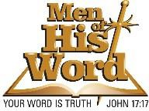

Sponsor/Exhibitor Registration Form 2024

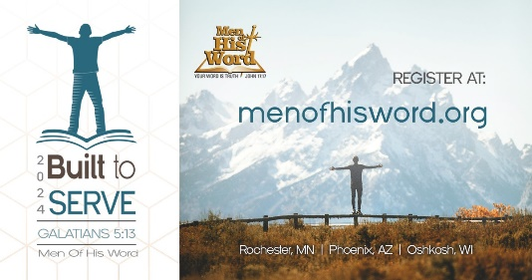
Business\Organization\Individual Name: _ Address: Email: Please send form and checks payable to:
Men of His Word
2207 11th Ave. SE
Rochester, MN 55902

Platinum Sponsor $1500+  - Please reserve a display table for me.  Please provide complimentary registrations for the following:  1.  2.  3.  4. | Gold Sponsor $1000+  - Please reserve a display table for me.  Please provide complimentary registrations for the following:  1.  2.  3.
Silver Sponsor $750+  - Please reserve a display table for me.  Please provide complimentary registrations for the following:  1.  2. | Bronze Sponsor $500+  - Please reserve a display table for me. Please provide complimentary registration for the following:  1.
Exhibitor $250  As an exhibitor a table will be reserved for you. Please provide complimentary registration for the following:  1. | Important Deadlines  - Conference Date: 10/26/2024  - Where: Mayo Civic Center  - Sponsors will be listed in the program

